*Heaven’s light is our guide.*

**Rajshahi University of Engineering and Technology**

**(RUET)**

**Department of Electrical & Electronic Engineering**

**Course no.** EEE2204

**Course title:** Electronics III Sessional

**Experiment no.** 04

**Experiment name:** Experimental study of a comparator and a Zero crossing detector circuit using Op-Amp.

**Submitted to:**

**Dr. Md. Samiul Habib**

Associate Professor

Dept. of Electrical & Electronic Engineering,

Rajshahi University of Engineering and Technology.

**Submitted by:**

**Ashraf Al- Khalique**

**Roll:** 1801171; **Session:** 2018-2019

Dept. of Electrical & Electronic Engineering,

Rajshahi University of Engineering and Technology.

**Date of experiment:** March 18, 2021.

**Date of submission:** March 24, 2021.

**Experiment no**. 04

**Name of the Experiment:** Experimental study of a comparator and a Zero crossing detector circuit using Op-Amp.

**Objectives:** Followings are the main objectives of this experiment,

1. To understand the theory of operation of a comparator and a Zero crossing detector circuit.
2. To study the Op-Amp applications in a comparator and a Zero crossing detector circuit.
3. To observe wave shapes that meet a comparator and a Zero crossing detector circuits’ needs.

**List of Components:**

1. Function Generator
2. DC power supply (61mV)
3. Resistors (1kΩ; 1 piece)
4. Op-Amp (µA741; 1 piece)
5. Oscilloscope
6. Project board
7. Connecting wires
8. Simulator (Multisim 11.0)

**Circuit diagram:**



***Fig 1.1:*** *Circuit diagram for a* *comparator circuit using Op-Amp.*

**

***Fig 1.2:*** *Circuit diagram for* *zero-crossing detector circuits using Op-Amp.*

**Waveshape:**

1. **Comparator circuit using Op-Amp:**

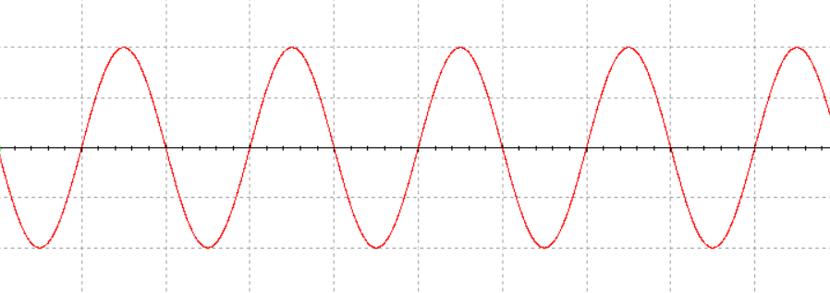

***Graph 1.1:*** *Input signal for* *a comparator circuit using Op-Amp.*

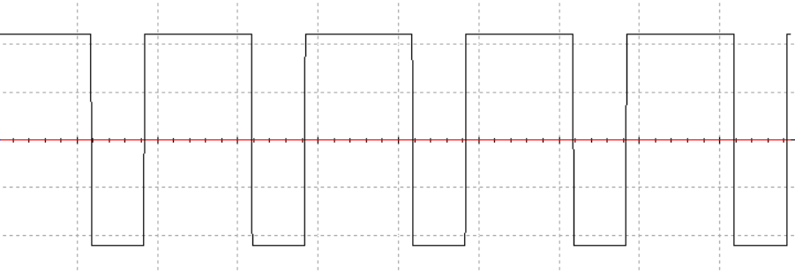

***Graph 1.2:*** *Output signal* *for a comparator circuit using Op-Amp.*

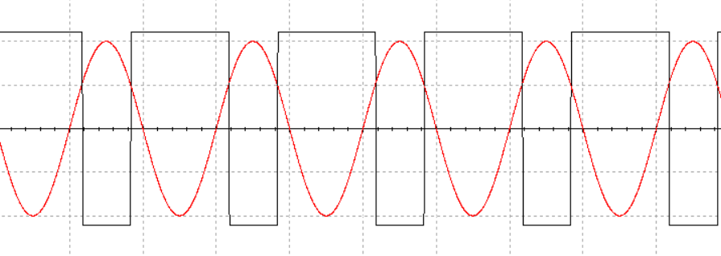

***Graph 1.3:*** *Input and output signal for a comparator circuit using Op-Amp.*

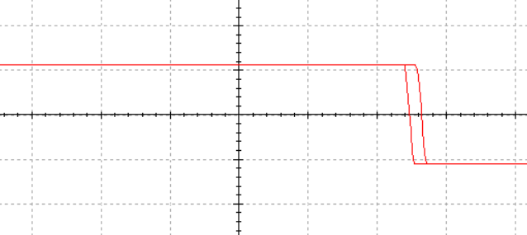

***Graph 1.4:*** *Transfer characteristics for a comparator circuit using Op-Amp.*

1. **Zero crossing detector circuits using Op-Amp:**

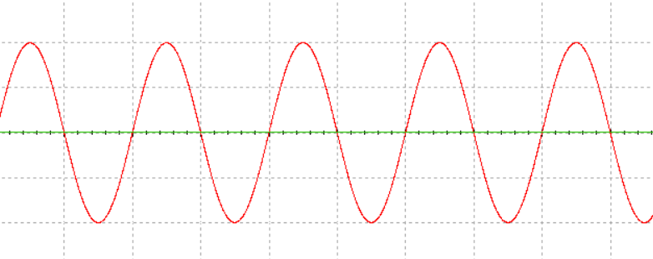

***Graph 2.1:*** *Input signal for zero-crossing detector circuits using Op-Amp.*

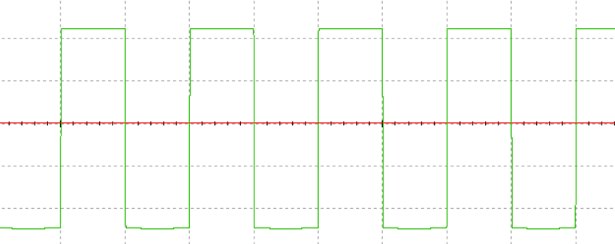

***Graph 2.2:*** *Output signal for zero-crossing detector circuit using Op-Amp.*

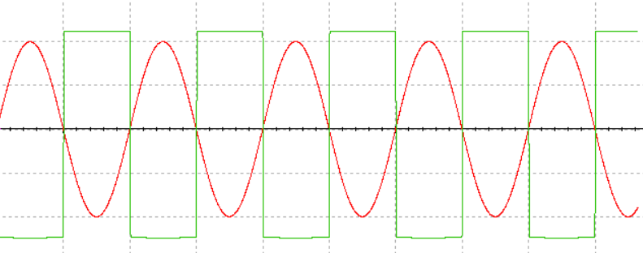

***Graph 2.3:*** *Input and output signal for zero-crossing detector circuits using Op-Amp.*

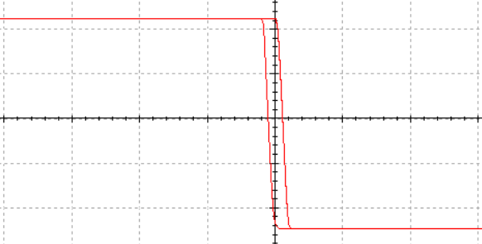

***Graph 2.4:*** *Transfer characteristics for a zero-crossing detector circuit using Op-Amp.*

**Result:**

In comparator circuit, for input sinusoidal signal, a digital signal with a positive peak of +Vcc and negative peak of –Vcc which intercepted the positive half cycle of input voltage at a reference voltage of 4.8V was found at the output.

In zero-crossing detector circuit, for input sinusoidal signal, a digital signal with –Vcc and Vcc peaks which crossed the input signal at zero voltage was obtained at the output.

**Conclusion:**